PROJECT REPORT OF MATLAB
by students: Baken Aibek
Mutali Darkhan

PROJECT 5 – ECONOMIC GROWTH MODEL (ECONOMIC/FINANCE)
INTRODUCTION
Economic growth is one of the central topics in macroeconomics.
The Solow growth model provides a simple but powerful framework for analyzing long-run economic growth driven by capital accumulation, population growth, and technological progress.
The objective of this project is to develop a computational simulator of the Solow growth model using MATLAB. The model is implemented mathematically, numerically, and visually through MATLAB scripts, Simulink, and an interactive graphical user interface (GUI).
The developed simulator allows users to explore the effects of key economic parameters on capital accumulation dynamics and steady-state outcomes.

- Mathematical Component
• Clear formulation of the problem
• Governing equations (ODEs, PDEs, algebraic systems)
• Initial and boundary conditions
• Assumptions and simplifications
• Analytical insights whenever possible
1.1 Clear formulation of the problem
The goal of this project is to model and simulate long-run economic growth using the Solow growth model, focusing on capital accumulation and its dependence on savings, population growth, depreciation, and technology.
We study how different parameter choices affect:
- Capital per worker
- Output per worker
- Steady-state equilibrium
- Transitional dynamics
  - Governing equations (ODEs, PDEs, algebraic systems)

Capital Accumulation (ODE)

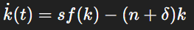
Where:
- k(t)k(t)k(t): capital per worker
- sss: savings rate
- nnn: population growth rate
- δ\deltaδ: depreciation rate
Production Function (Cobb–Douglas)
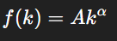
Where:
- AAA: technology level
- α∈(0,1)\alpha \in (0,1)α∈(0,1): capital elasticity

  - Initial and boundary conditions

The initial condition for the model is given by:
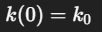
where k0k_0k0​ represents the initial level of capital per worker.

  - Assumptions and simplifications
The model is based on the following assumptions:
• Closed economy (no government or trade)
• Constant savings rate
• Exogenous population growth
• Exogenous technological progress (constant AAA)
• Perfect competition
• Diminishing returns to capital

  - Analytical insights whenever possible

Steady State
At steady state:
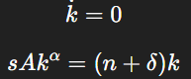
Solving:
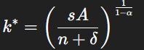
Corresponding output:
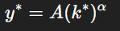

Comparative Statics
- ↑ savings → ↑ steady-state capital
- ↑ population growth → ↓ steady-state capital
- ↑ technology → ↑ output and capital

- MATLAB Implementation
• The computational model must use multiple topics from the lecture list (MATLAB scripting, matrix methods, plotting, optimization, GUI, OOP, Simulink, special functions, PDE solving, numerical calculations, etc.) Includes either: o o a GUI Application, or a Simulink Model that allows the end user to test the system using different parameter sets or datasets.
MATLAB Numerical Implementation
The differential equation of the Solow model is solved numerically using MATLAB’s built-in ODE solver ode45.
The numerical implementation consists of:
- a function file defining the differential equation,
- a main script that initializes parameters and solves the model,
- visualization of capital and output dynamics over time.
This approach allows verification of model behavior and comparison with analytical steady-state values.

MATLAB Code Implementation
This section describes the MATLAB scripts and functions developed for the numerical implementation of the Solow growth model.
solow_ode.m — Model Definition

The file solow_ode.m defines the differential equation of the Solow growth model.
It implements the law of motion for capital per worker:
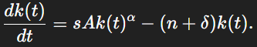
The function takes time, capital, and a structure of parameters as inputs and returns the instantaneous rate of change of capital.
Encapsulating the model equation in a separate function improves modularity and allows reuse of the model definition across different numerical experiments.
Key features:
- Clear separation between model equations and numerical solvers
- Parameter handling through a structured input
- Compatibility with MATLAB ODE solvers
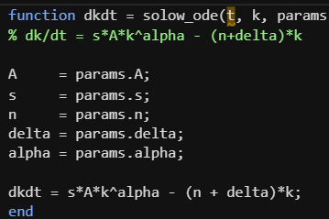
run_solow.m — Numerical Simulation Script
The script run_solow.m performs numerical simulation of the Solow growth model using MATLAB’s ode45 solver.
The script initializes model parameters, sets the initial condition, and defines the simulation time horizon. The differential equation is solved numerically, and the resulting capital and output trajectories are visualized.
In addition, the script computes the analytical steady-state capital level and displays it on the simulation plot for comparison with the numerical solution.
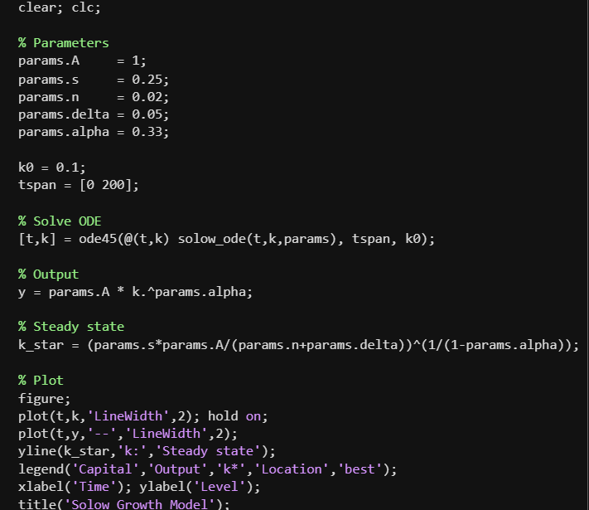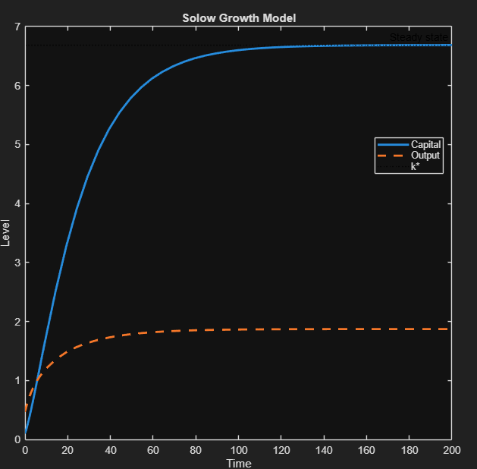
Main tasks performed by the script:
- Initialization of economic parameters
- Numerical integration of the model
- Computation of steady-state values
- Visualization of simulation results
solow_params.m — Parameter Configuration for Simulink
The file solow_params.m contains the parameter definitions used by the Simulink model.
Running this script loads all economic parameters into the MATLAB workspace, making them accessible to Simulink blocks during simulation.
This design ensures consistency between the MATLAB and Simulink implementations and allows easy experimentation with different parameter values.
Advantages of this approach:
- Centralized parameter management
- Consistent parameter values across different implementations
- Improved readability and maintainability of the code
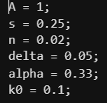

App Designer File (SolowApp.mlapp)
The App Designer file implements an interactive graphical user interface for the Solow growth model.
The application integrates numerical computation and visualization, allowing users to change parameters and observe the resulting dynamics in real time.
The GUI internally calls MATLAB numerical routines and updates graphical outputs and steady-state indicators based on user input.
GUI functionalities include:
- Interactive parameter input
- Dynamic plot generation
- Automatic steady-state computation
- User-friendly visualization for educational use
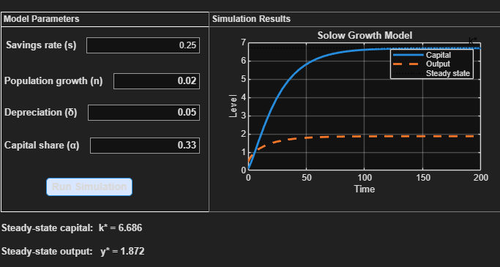

Code Organization and Design Choices
The MATLAB code is organized into separate files according to functionality:
- model definition,
- numerical simulation,
- parameter management,
- user interface.
This modular design improves clarity, reusability, and scalability of the project, and follows good programming practices for scientific computing.

Results (Simulation Results)
Numerical simulations show that capital per worker increases over time and converges to a stable steady-state level.
The transition dynamics depend on the initial level of capital and the values of economic parameters. In all simulations, the system exhibits monotonic convergence without oscillations, which is consistent with the theoretical properties of the Solow model.
The steady-state values obtained numerically coincide with the analytical expressions derived earlier, confirming the correctness of the implementation.

Discussion (Interpretation of Results)
The simulation results illustrate the key mechanisms of the Solow growth model.
An increase in the savings rate leads to higher steady-state levels of capital and output, as a larger fraction of output is invested.
In contrast, higher population growth and depreciation rates reduce steady-state capital by increasing the effective dilution of capital.
The results highlight the role of savings behavior and demographic factors in determining long-run economic outcomes, while technological parameters shape the productivity of capital.

Validation and Consistency Check

The consistency of the model implementation is verified by comparing analytical, numerical, and simulation-based results.
The steady-state values computed analytically match those obtained from MATLAB numerical simulations and Simulink models.
This agreement confirms the correctness of the mathematical formulation and the reliability of the computational implementation.
Conclusion

This project presented a comprehensive implementation of the Solow growth model using MATLAB.
By combining analytical derivation, numerical simulation, Simulink modeling, and an interactive graphical interface, the project provides a complete framework for studying economic growth dynamics.
The developed tools are suitable for educational purposes and can be extended to include technological progress or policy analysis in future work.

